**ME6406 HW1 Thanakorn Khamvilai Report**

Problem 1: Pin-Hole Optics

Solution:

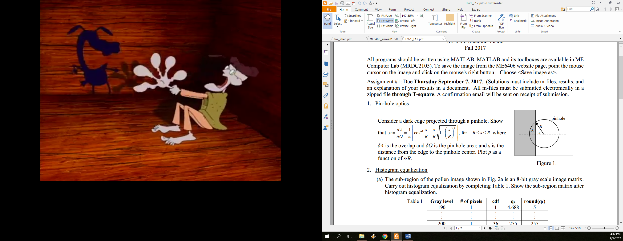 Pin-hole area $δO= πR^{2}$

Consider the right triangle

$$θ$$

R

sR

The angle $θ= arccos\frac{s}{R}$

and the area

A1

R

R

A2

Consider the Sector

The area $A_{2}=πR^{2}∙\frac{2θ}{2π}$

$A_{2}=θR^{2}$

$A_{2}=arccos\frac{s}{R}∙R^{2}$

Then the overlap area $δA= A_{2}-A_{1}$

$δA= arccos\frac{s}{R}∙R^{2}-2∙\frac{1}{2}s\sqrt{R^{2}-s^{2}}$

$δA= R^{2}\left[arccos\frac{s}{R}-\frac{s}{R}\sqrt{1-{\left(\frac{s}{R}\right)}^{2}}\right]$

Therefore, $ρ= \frac{δA}{δO}=\frac{R^{2}\left[arccos\frac{s}{R}-\frac{s}{R}\sqrt{1-{\left(\frac{s}{R}\right)}^{2}}\right]}{πR^{2}}$

$ρ= \frac{1}{π}\left[arccos\frac{s}{R}-\frac{s}{R}\sqrt{1-{\left(\frac{s}{R}\right)}^{2}}\right]$

Plot ρ as a function of s/R using MATLAB (HW1_1.m)

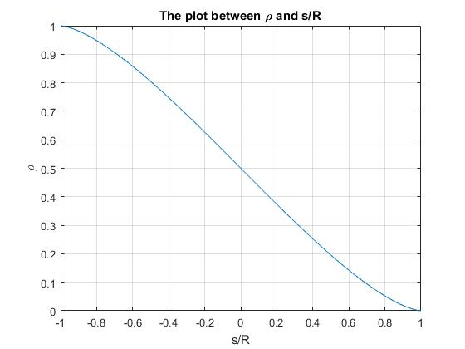

Problem 2: Histogram Equalization

2a) Solution: The table below was done using MATLAB (HW1_2a.m)

|  |  |  |  |  |
| --- | --- | --- | --- | --- |
| **Gray Level** | **# of pixels** | **cdf** | **qk** | **round(qk)** |
| 190 | 1 | 1 | 7.0833 | 7 |
| 191 | 5 | 6 | 42.5000 | 43 |
| 192 | 3 | 9 | 63.7500 | 64 |
| 193 | 5 | 14 | 99.1667 | 99 |
| 194 | 4 | 18 | 127.5000 | 128 |
| 195 | 7 | 25 | 177.0833 | 177 |
| 196 | 6 | 31 | 219.5833 | 220 |
| 197 | 2 | 33 | 233.7500 | 234 |
| 198 | 1 | 34 | 240.8333 | 241 |
| 199 | 1 | 35 | 247.9167 | 248 |
| 200 | 1 | 36 | 255.0000 | 255 |

2b) Solution: I. Read in and display the ‘teeth.jpg’ (HW1_2b.m)

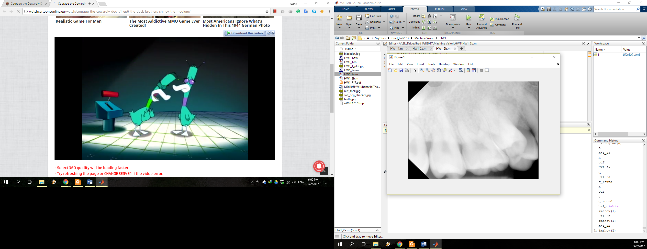

II. Compare by displaying the original and processed images and their histograms. (HW1_2b.m)

By using codes from 2a)

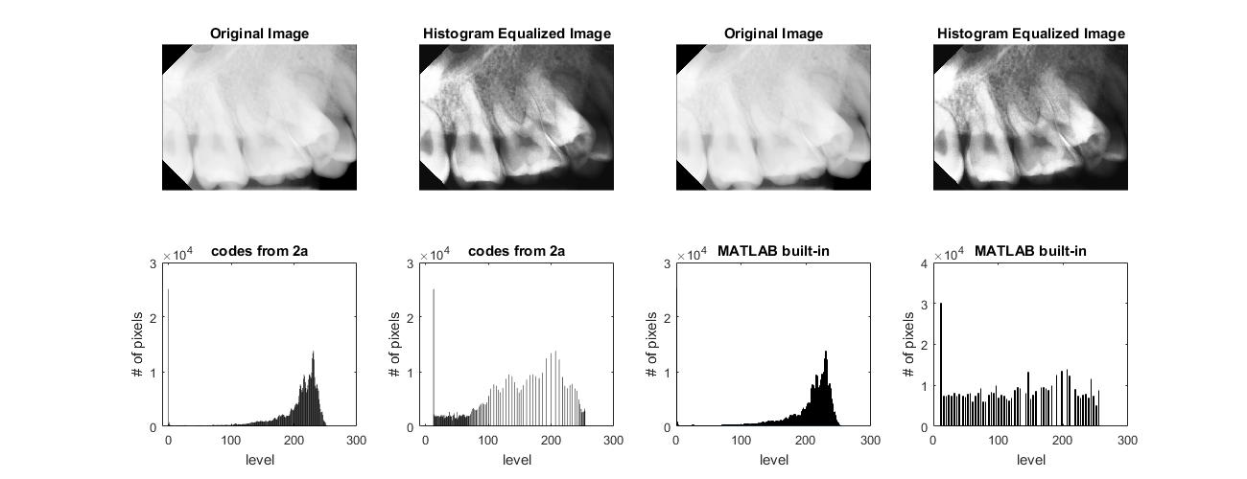

By using MATLAB built-in commands



There is a little difference in pixel intensity obtained from these two approaches even if both equalized images look pretty similar; thus, the plots of histogram equalization are difference.

Problem 3: Filtering Masks

3a) Solution:

$$H_{x}=\left[\begin{matrix}-1 & -2 & -1 \\ 0 & 0 & 0 \\ 1 & 2 & 1\end{matrix}\right], H_{y}=\left[\begin{matrix}-1 & 0 & 1 \\ -2 & 0 & 2 \\ -1 & 0 & 1\end{matrix}\right],Z=\left[\begin{matrix}199 & 197 & 195 \\ 197 & 195 & 194 \\ 196 & 194 & 192\end{matrix}\right]$$

$$g_{m}=196+2\left(194\right)+192-199-2\left(197\right)-195=-12$$

$$g_{n}=195+2\left(194\right)+192-199-2\left(197\right)-196=-14$$

Magnitude

$$\left|g(m.n)\right|=\sqrt{g_{m}^{2}+g_{n}^{2}}=\sqrt{{\left(-12\right)}^{2}+{\left(-14\right)}^{2}}=18.4391≈18$$

Direction

$$∠g\left(m,n\right)=\tan^{-1}\frac{g_{n}}{g_{m}}=\tan^{-1}\frac{-14}{-12}={229.3987}^{o}$$

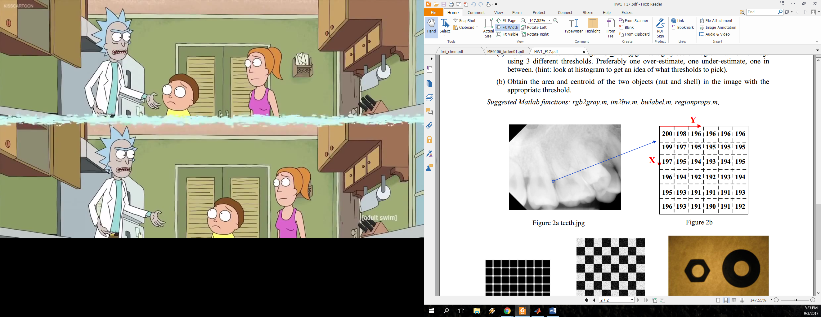

**229.3987o**

3b) Solution: This problem was done using MATLAB (HW1_3b.m)

Original Image

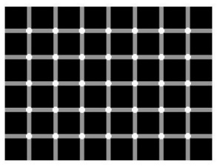

Using the same calculation as 3a)

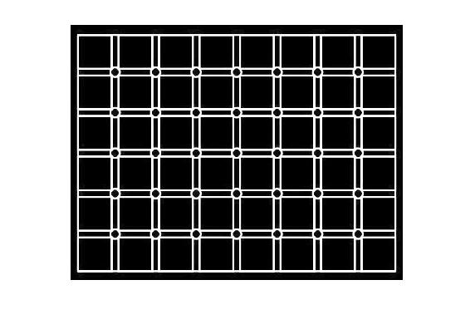 Both Direction Vertical Direction Horizontal Direction

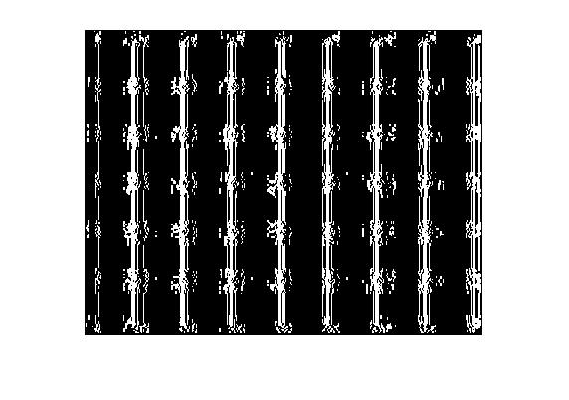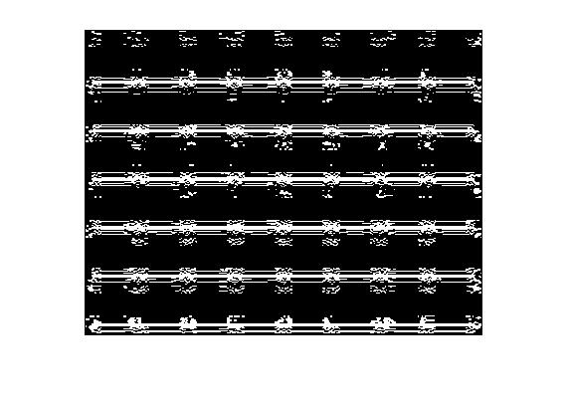

Using the MATLAB built-in command with the default threshold

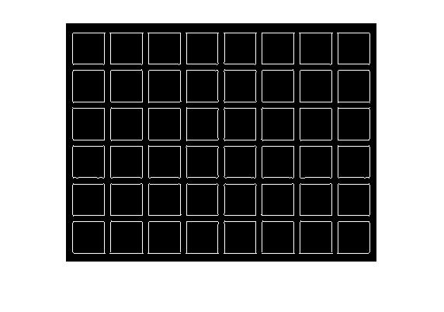 Both Direction Vertical Direction Horizontal Direction

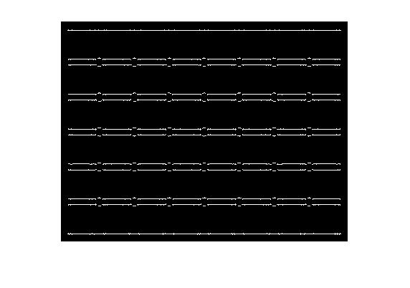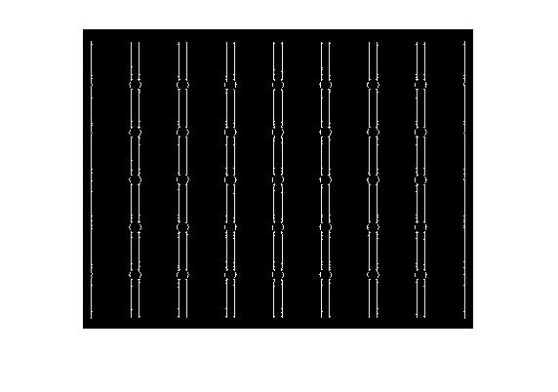

Because of using the default threshold in built-in *edge* command, the results from these two approaches have some differences.

3c) Solution: This problem was done using MATLAB with 3Std Gaussian Filter i.e.7x7 for σ = 1 (3*1*2 + 1), 13x13 for σ = 2 (3*3*2 + 1), and 31x31 for σ = 5 (3*5*2 + 1) (HW1_3c.m)

Original Image

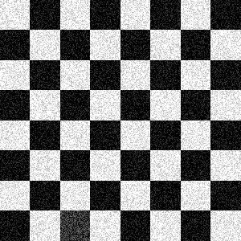

Analytical Implement MATLAB Built-In Command

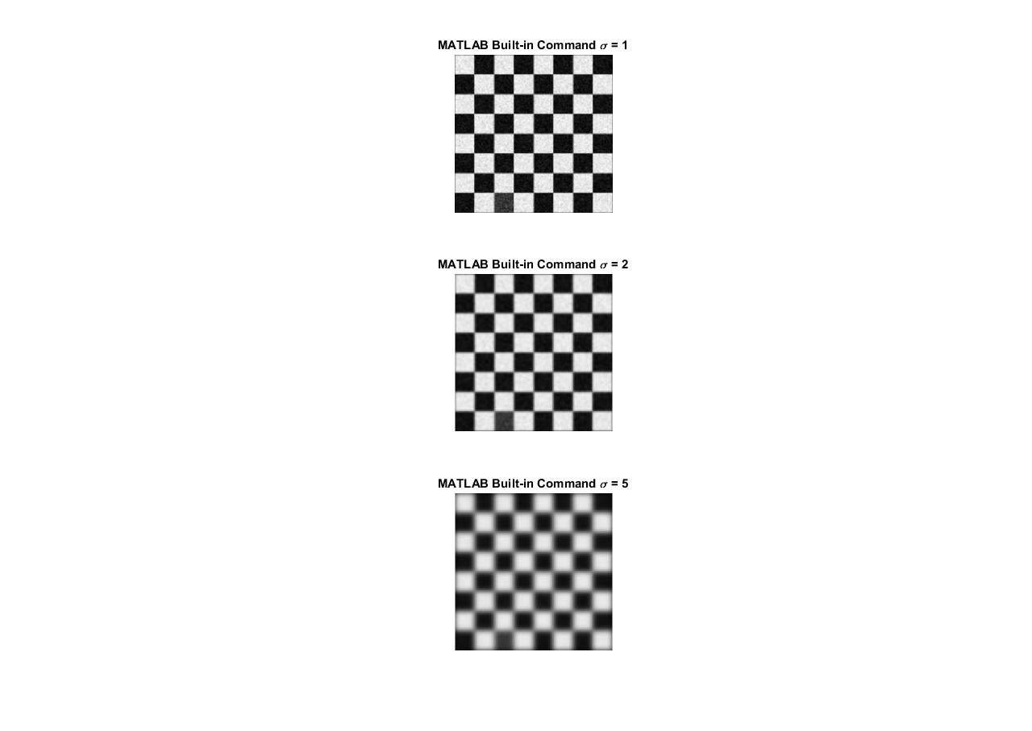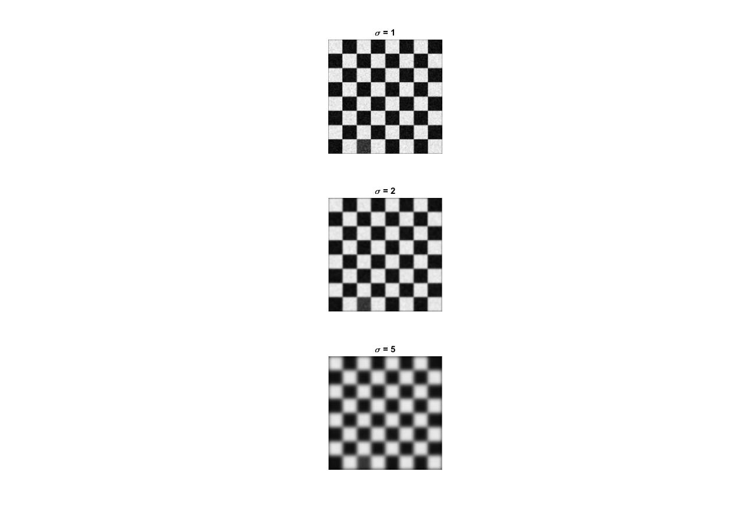

Problem 4: Low-Level Information Processing

4a) Solution: This problem was done using MATLAB (HW1_4a.m)

Original Image Grayscale Image

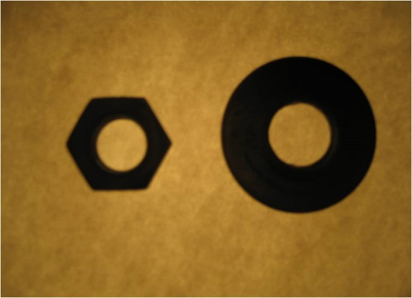 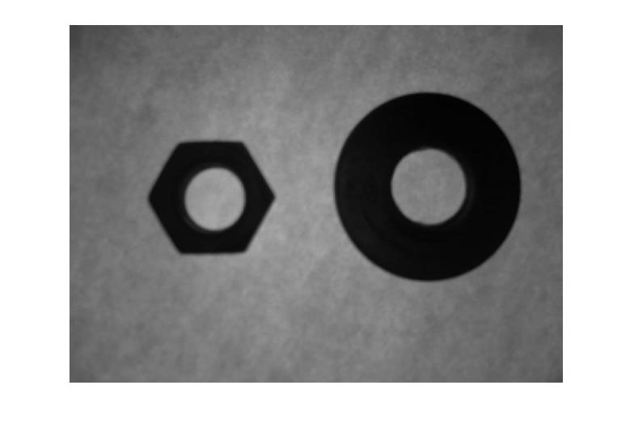

Over-Estimated Threshold Under-Estimated Threshold

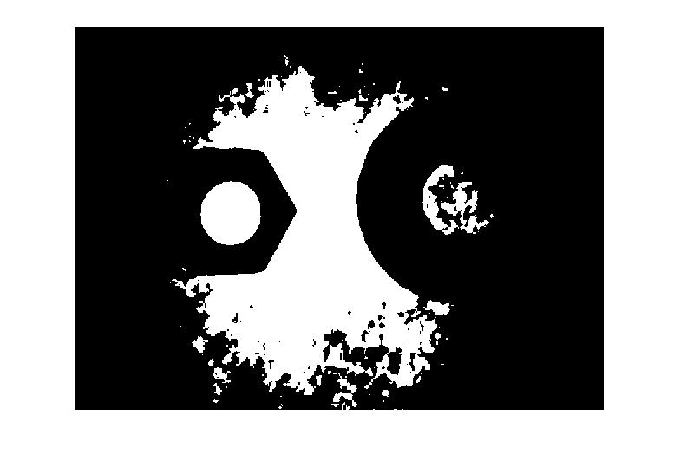 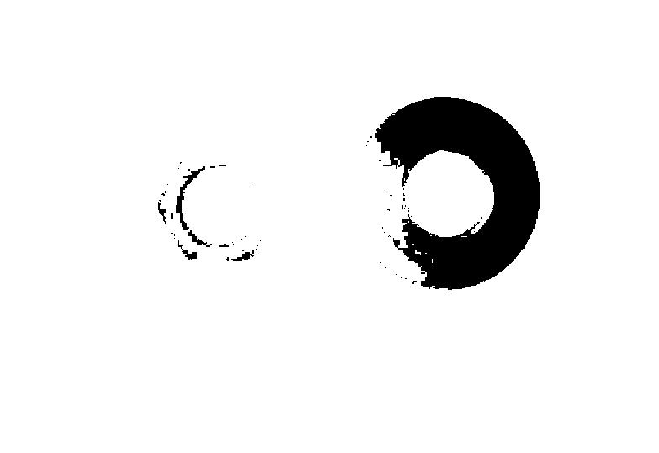

Appropriated Threshold Histogram

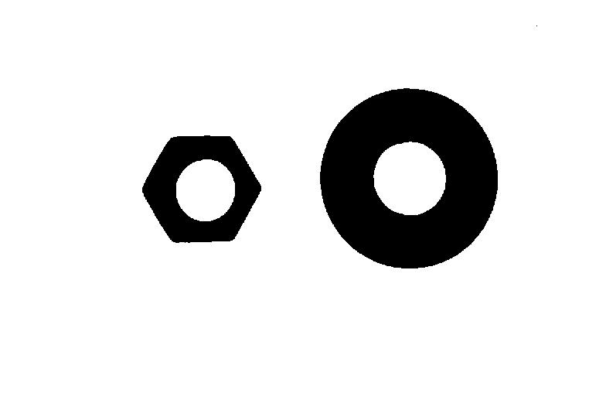 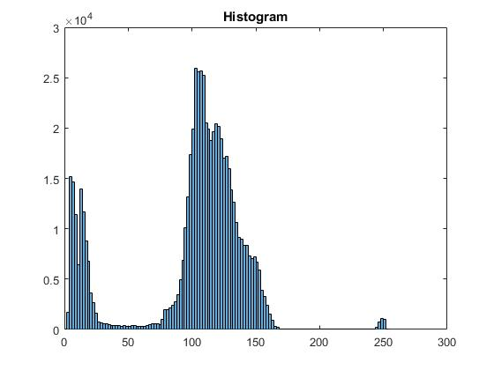

The values of over-estimated threshold, under-estimate threshold, and appropriated threshold are chosen to be 127.5, 12.75, and 51, respectively; hence, the values 0.5 (127.5/255), 0.05 (12.75/255), and 0.2 (51/255) are used in *im2bw* function for over-estimated threshold, under-estimate threshold, and appropriated threshold, respectively.

4b) Solution: This problem was done using MATLAB (HW1_4b.m)

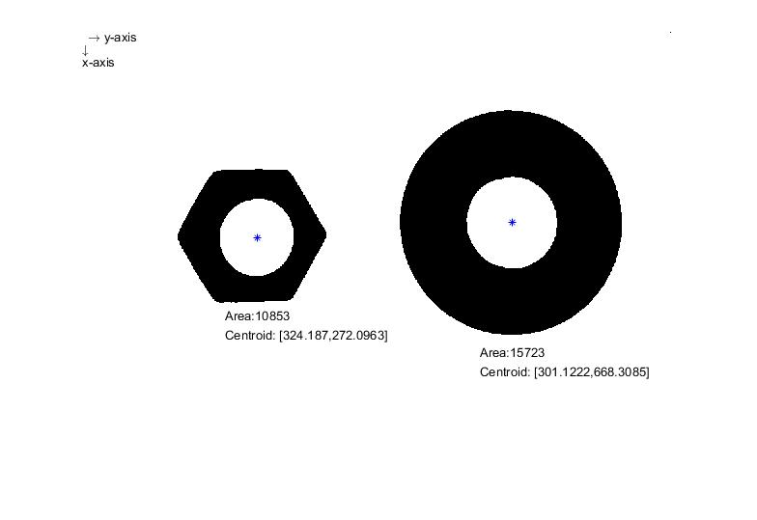

The directions of axes, the locations of centroids, and the areas of each nut are already labeled on the above figure.